Team BMP’s Work-time Journal?

Beginning of Second week:

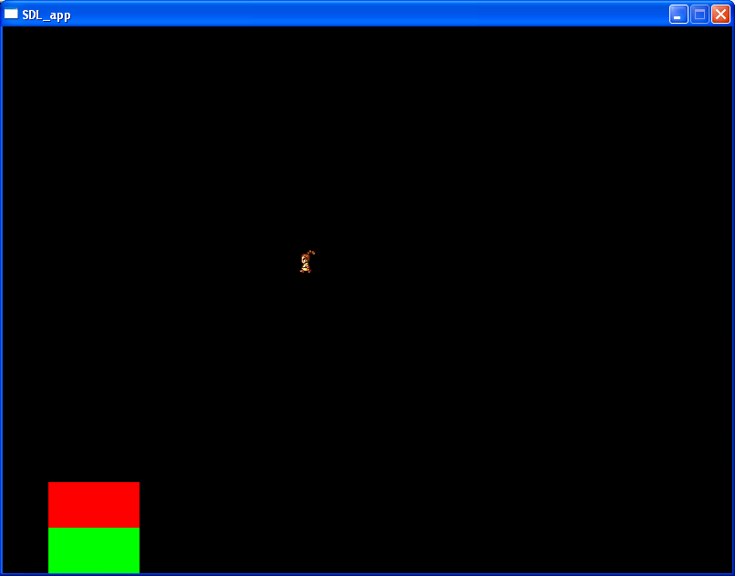

A sprite can be moved around in the world, with the Health and Energy display on the lower left.

Problems Encountered:

Matt: Not many problems. A lack of communication with a quarter of the team, some confusion and hesitation on what needs to be done next.

Monday of Week 3:

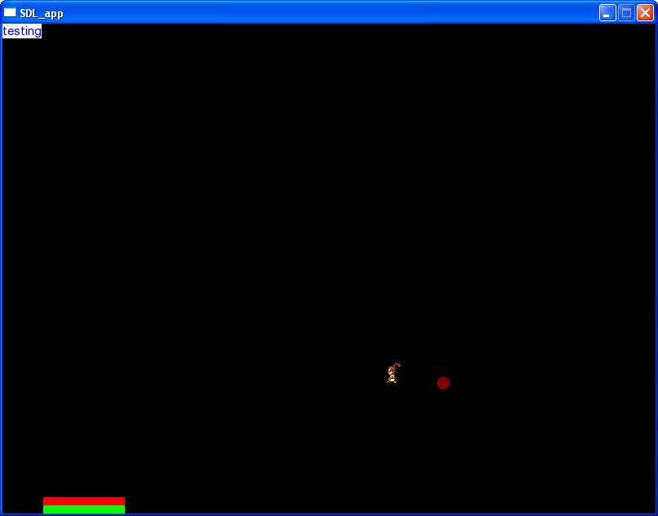

Testing of True Text Font, a fireball can move, and the HUD is moved down and made smaller. Sprite can still move.

Comments from the Team:

Matt; Little lack of communication again, that seems to be our biggest issues, along with one person not SHOWING their work (we know he’s working, we just don’t have any proof yet.)

Thursday of Week 4:

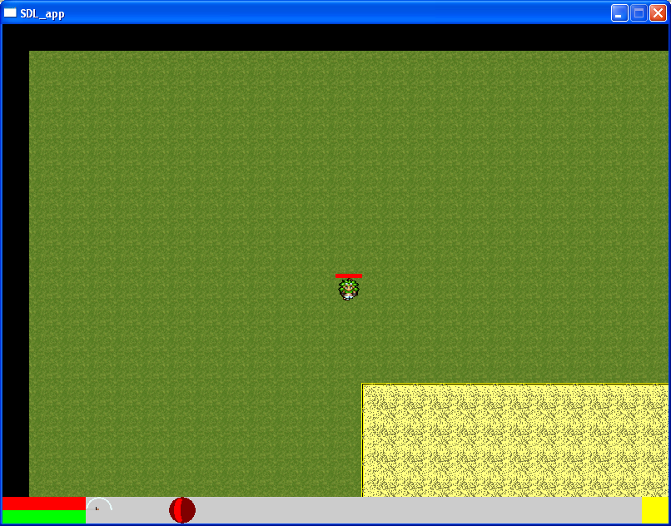

Lot of stuff done these last two weeks: sprites can move, health bar, stat screen by pressing the yellow HUD button, map system is loaded from a file, the tiles move around the screen, basic fireball, ring of fire, and Armageddon are in and can be switched using the 1-4 and 5-8 keys. And there’s a slash. Basic basic networking is in, as in now there’s a client and a server.

Comments from the team:

Matt: Holy cow, I did not realize we got so much stuff done. There was a major update that was skipped, namely in that the map system started working, but this was the main TileSet. Also, Jared got the base engine done and so now all that’s left is integration, and a shitton more. Wow this game’s gonna be awesome.

Beginning of 5th Week:

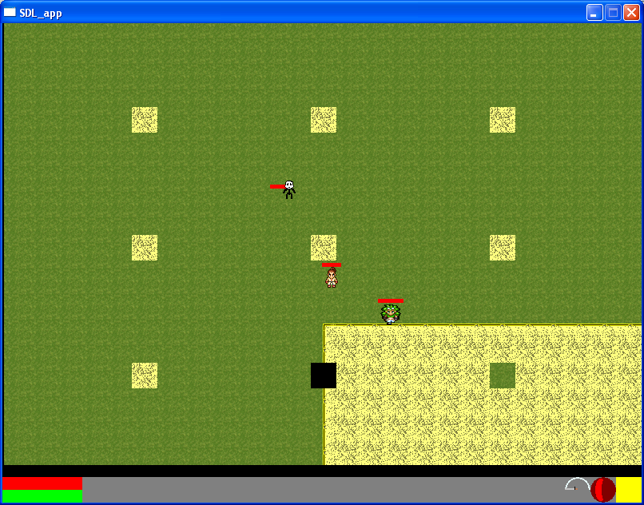

Moveable world, Tile collision, Entity Collision, a semi Map Editor, and more networking involvement.

Quotes from the Playe…developers.

Matt: One person down due to sickness for the last couple of weeks, but we’re moving along. We’re slightly behind schedule right now so we need to pick up the pace.

Thursday of Week 6

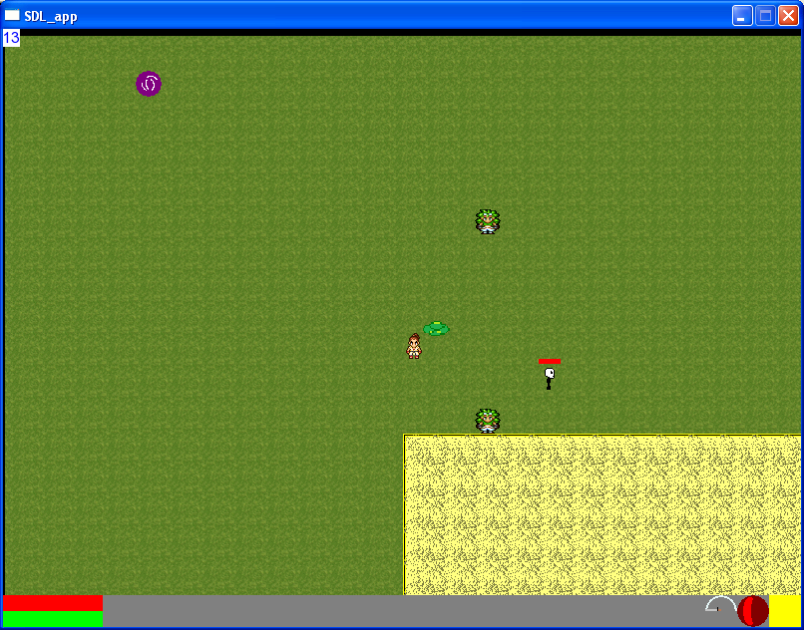

Changed to Real-Time, added a slime in there, added NPC’s and dialogue, and added a WORKING PORTAL. Whoo!

Comments from Dev’s:

Matt: Not a whole lot seen from Jared, but wow we got stuff done over the last few weeks. It’s hard to believe that we did all this stuff IN SIX WEEKS.

Thursday of Week 7:

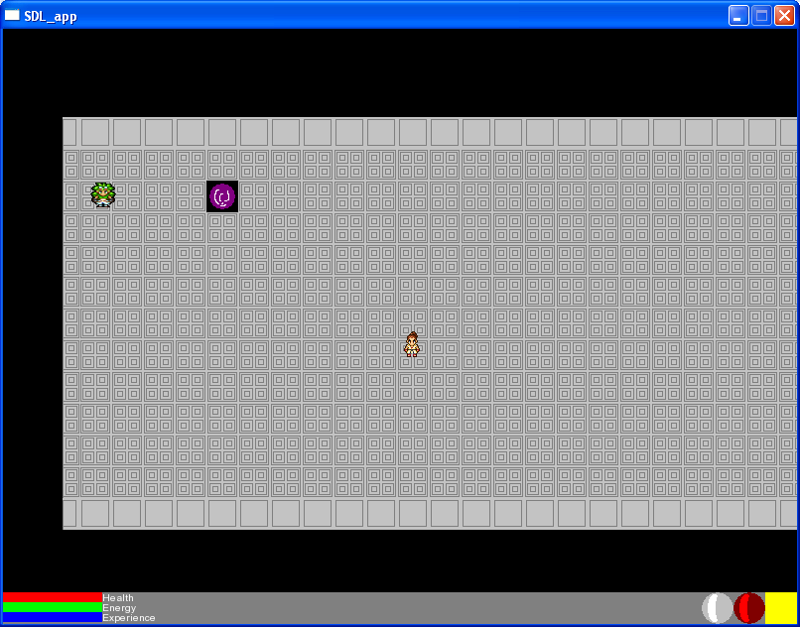

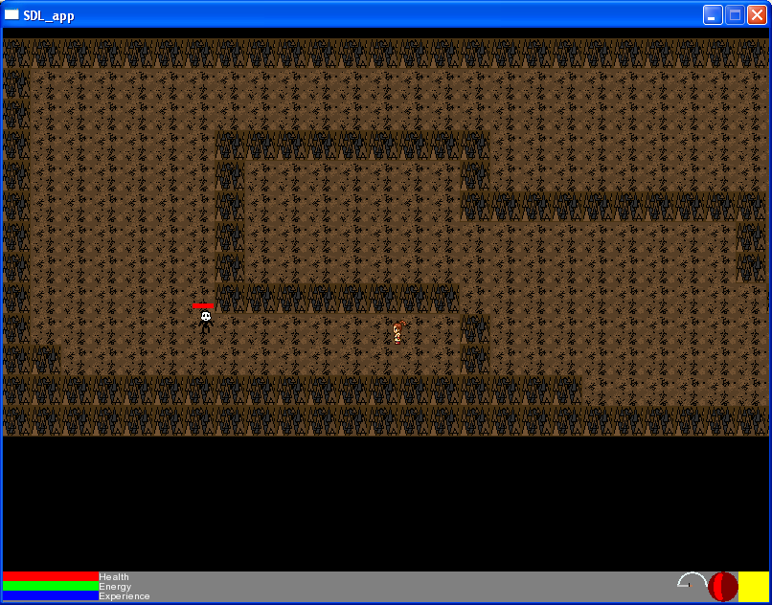

Stuff done this week:

Dungeon added, NPC’s read from files added, blunt and divine magic added, added in experience system, added secondary blunt and slash skills, stat progression added.

Comments from Team Members -1;

Matt: We lost Jared this week. I was working on the TDD and GDD so I didn’t get as much done as I’d needed/wanted to.

Beginning of Week…9 I think:

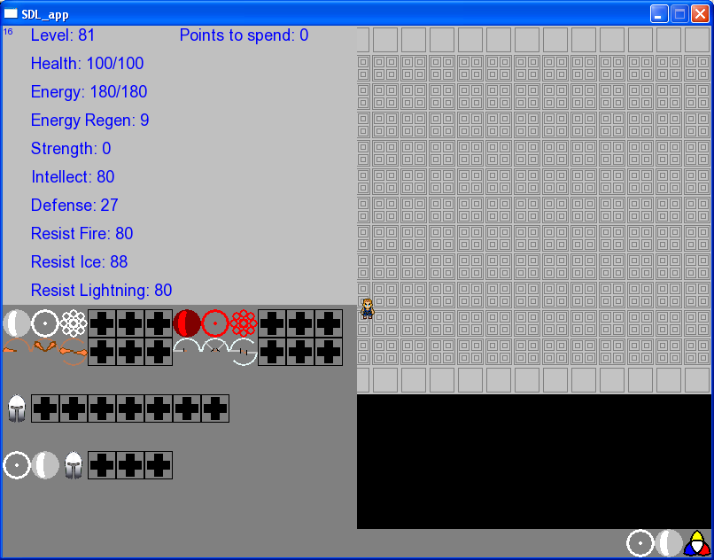

Things we’ve accomplished as of late: Changed up the status up screen, as is obvious. Now it shows the entire inventory as well. Those blank spots are places where the player may not have the chips yet. The stat up icon is new as well, and when you level up it rotates around getting your attention. Chips and armor are saved as well as what order in the gauntlet they are. More worlds as well, such as a Castle now, complete with Knights. Trees are obstacles as well, hopefully making the medieval world less boring.

Comments from the Team:

Matt: We got Joe last week. Or was last week week 8? Is this week week 10? I can never figure this out… Anyway after Jared left stuff went down, we got a new teammate, took a week off due to break where we all had a variety of reasons to ignore the project, and…I took up the handle of networking now that we’re actually taking the CLASS and now some stuff about how it works. This is gonna be both a pain and a headache, isn’t it?